**Topics: Descriptive Statistics and Probability**

1. Look at the data given below. Plot the data, find the outliers and find out $μ, σ, σ^{2}$

|  |  |
| --- | --- |
| **Name of company** | **Measure X**  24.23%  25.53%  25.41%  24.14%  29.62%  28.25%  25.81%  24.39%  40.26%  32.95%  91.36%  25.99%  39.42%  26.71%  35.00% |
| Allied Signal |
| Bankers Trust |
| General Mills |
| ITT Industries |
| J.P.Morgan & Co. |
| Lehman Brothers |
| Marriott |
| MCI |
| Merrill Lynch |
| Microsoft |
| Morgan Stanley |
| Sun Microsystems |
| Travelers |
| US Airways |
| Warner-Lambert |

**ANS :**

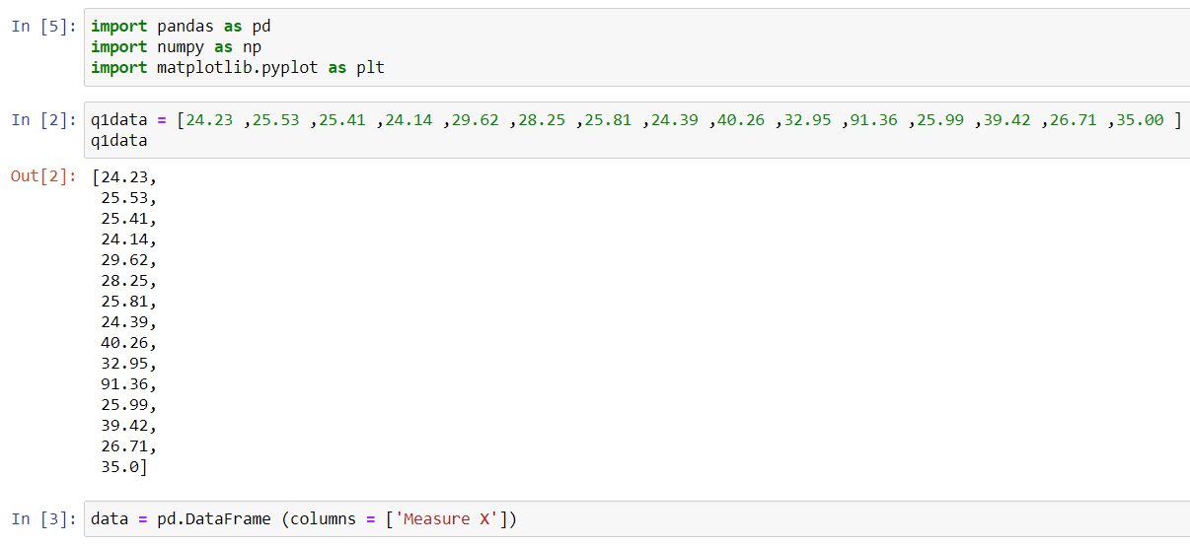

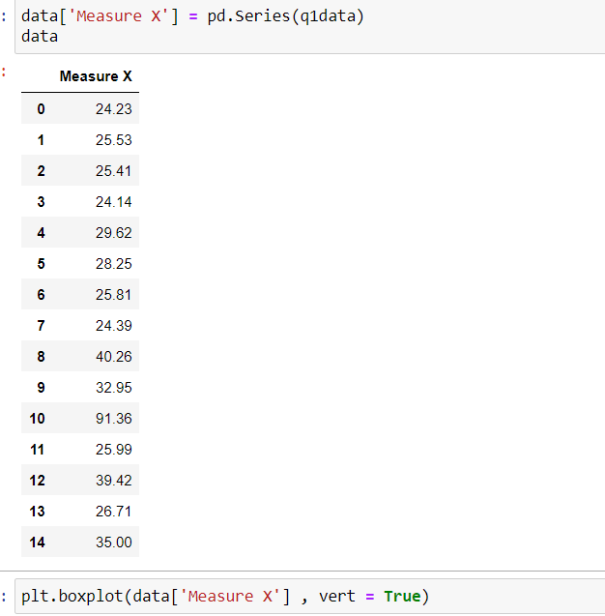

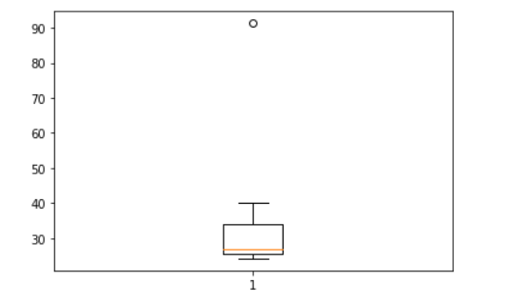

Morgan Stanley with 91% is the outlier

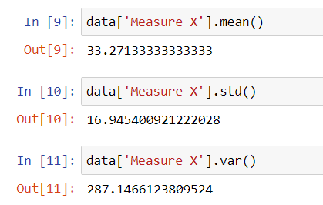



Answer the following three questions based on the box-plot above.

1. What is inter-quartile range of this dataset? (please approximate the numbers) In one line, explain what this value implies.

**ANS :**

Q1 = 5

Q3 = 12

IQR = Q3-Q1 = 12-5 = 7

1. What can we say about the skewness of this dataset?

**ANS :** Positive skewness

1. If it was found that the data point with the value 25 is actually 2.5, how would the new box-plot be affected?

**ANS :** Then the data point will no longer be an outlier but will only be present in one of the whiskers below the 10th percentile



Answer the following three questions based on the histogram above.

1. Where would the mode of this dataset lie?

**ANS :**  It would lie between 4 to 8

1. Comment on the skewness of the dataset.

**ANS** : Positive skewnss

1. Suppose that the above histogram and the box-plot in question 2 are plotted for the same dataset. Explain how these graphs complement each other in providing information about any dataset.

**ANS** : Both these graphs can tell us that there is an outlier value as well as that the data is positively skewed

1. AT&T was running commercials in 1990 aimed at luring back customers who had switched to one of the other long-distance phone service providers. One such commercial shows a businessman trying to reach Phoenix and mistakenly getting Fiji, where a half-naked native on a beach responds incomprehensibly in Polynesian. When asked about this advertisement, AT&T admitted that the portrayed incident did not actually take place but added that this was an enactment of something that “could happen.” Suppose that one in 200 long-distance telephone calls is misdirected. What is the probability that at least one in five attempted telephone calls reaches the wrong number? (Assume independence of attempts.)

**ANS :**

: X = probability of 1 call misdirected out of 200

Probability of occurring of X = 1/200

P(X)= 1/200

Probability of having at least one successful call will be

1-P(X)= 1-1/200= 199/200= 0.967

As every event is independent of other event the probability will be

1- (0.967)^5

0.02475 = 2% chance

1. Returns on a certain business venture, to the nearest $1,000, are known to follow the following probability distribution

|  |  |
| --- | --- |
| x | P(x) |
| -2,000 | 0.1 |
| -1,000 | 0.1 |
| 0 | 0.2 |
| 1000 | 0.2 |
| 2000 | 0.3 |
| 3000 | 0.1 |

1. What is the most likely monetary outcome of the business venture?

**ANS** : $2000 as it has the highest probability of occurrence

1. Is the venture likely to be successful? Explain

**ANS** : Yes it is likely to be successful because the probability of getting a profit which is 0.6 , and it is more likely to occur compared to a loss whose probability is 0.2

1. What is the long-term average earning of business ventures of this kind? Explain

**ANS** : (-2000*0.1)+(-1000*0.1)+(0*0.2)+(1000*0.2)+(2000 *0.3)+(3000*0.1)=800

the long-term average earning for these type of ventures would be around $800

1. What is the good measure of the risk involved in a venture of this kind? Compute this measure

**ANS** : The measure of risk can be found out using standard deviation which is $1870